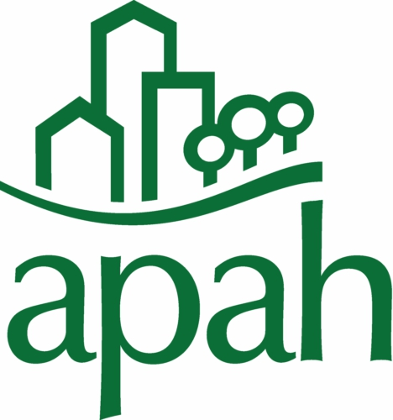
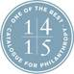

NEWS RELEASE For more information
Cheryl Ramp
(703) 276-7444, ext. 102
(703) 966-6603 (cell)
cramp@apah.org

Arlington Partnership for Affordable Housing
Selected by Citi Foundation’s
Community Progress Makers Fund Grant Program
to Accelerate Economic Opportunity

Arlington-based Community Progress Maker Joins Leading Nonprofit Organizations Across the United States to Address Urban Challenges Ranging from Affordable Housing to Environmental Sustainability and Infrastructure

Arlington, VA – MAY 18, 2016 – Arlington Partnership for Affordable Housing (APAH) announced today that it has been selected as a recipient of the Community Progress Makers Fund, a $20 million grant initiative to support 40 visionary nonprofit organizations in their efforts to establish new approaches to long-standing urban economic challenges in the United States – including economic development, environment sustainability, urban infrastructure, and affordable housing.

As part of the program, APAH will receive a core operating support grant of $500,000 over the course of two years to continue its work in the community around affordable housing. This new injection of funds will help bolster existing initiatives while opening up the door to additional programs to help low income Arlingtonians build assets and thrive in the Arlington community. In addition to the grant, APAH will also have access to technical assistance from leading national researchers and experts and will be provided opportunities to connect with other grantees to share and learn best practices.

“APAH is honored and thrilled to be selected for this prestigious award,” said APAH President and CEO Nina Janopaul. “Quality housing is the critical first step to creating a stable foundation for low income Arlington residents. As a Community Progress Maker, APAH will accelerate our work to develop urgently needed affordable housing and will expand our partnerships with organizations across the County to help low income families succeed.”

“The Citi Foundation feels privileged to support organizations that have demonstrated such strong commitments to their local communities and a willingness to share their experiences with others for the betterment of their neighborhoods,” said Brandee McHale, President of the Citi Foundation. “These organizations have a track record of implementing solutions that work for their communities because they know the people there, understand what resources to tap and, most importantly, feel deeply invested in the places where they live and work. We believe that’s the key to leading urban transformation efforts in Arlington and elsewhere across the country.”

The Community Progress Makers Fund builds upon the Citi Foundation’s commitment to identify and support innovative solutions and organizations that are helping build stronger, more resilient cities that are engines of economic opportunity for all. The flexibility of core operating support will allow organizations and their visionary leaders to deploy solutions that address a range of issues.

###

About Arlington Partnership for Affordable Housing (APAH)

APAH is a nonprofit that develops, preserves, owns, and advocates quality rental housing that is affordable to low and moderate-income families and promotes opportunity for residents through partnerships and programs. APAH works exclusively in Arlington County. Founded in 1989, APAH now helps 1200 households live in stable, secure and affordable rental homes. In 2014 APAH was named Developer of the Year by the Housing Association of Nonprofit Developers (HAND) and APAH’s Arlington Mill Residences was awarded Best Housing Development in Virginia at the Virginia Governor’s Housing Conference.

About the Citi Foundation
The Citi Foundation works to promote economic progress and improve the lives of people in low-income communities around the world. We invest in efforts that increase financial inclusion, catalyze job opportunities for youth, and reimagine approaches to building economically vibrant cities. The Citi Foundation's "More than Philanthropy" approach leverages the enormous expertise of Citi and its people to fulfill our mission and drive thought leadership and innovation. For more information, visit www.citifoundation.com.

